Meeting Name: | WIC-Northwest District | Date: | Thursday, October 25, 2018
Facilitator: | LaKeisha Davis | Time: | 2pm-4pm
Documented by: | LaKeisha Davis | Location: | Swope Health Services  3801 Blue Parkway  Kansas City, MO 64130  HR training room (2nd Floor)  Conference Call Line: 866-630-9346

Attendees
Doug McKeever- Distr TA | Ernestine Persley- Distr TA
Basima Byazaid- Crescent | LaKeisha Davis- Swope
Heidi Loecke- Platte Co
Jamie Ayers- Caldwell Co
Tammy Clough- Clinton Co

Agenda
Introductions
Missouri WIC Association (MWA) updates
Missouri WIC Conference feedback?
Q&A Ernestine?
Q&A Doug?
Issues/Concerns/Ideas?
Action Items: | Responsible Parties | Deadline -Completion
Board member info | LaKeisha
Where will agency info on eCards go? | Doug
Survey availability for next meeting | LaKeisha
Notes
MWA-
Last meeting was held August 8th
- Distr Reps reported
- Miller Co recently learned that DCN’s do not need to be assigned because they upload from PROD. Doug confirmed DCN’s reconcile from social services each night with auto input.
- Finalized WIC conference plans
- Angela and Kathy shared a few updates at State
- eWIC kick off meeting was held August 21st at the state which included pilot agencies, banks, data processing, USDA
- anticipating Spring 2019 roll out of eWIC
- eWIC facts sheet will be coming out soon
- The state is looking into a shopper app for client use that is compatible with MOWINS
- WIC funding formula is being reviewed due to decrease in caseload statewide
- Local agencies are encouraged to attend the statewide Public Health Agency meeting in January in Jeff City if and administrator from your organization is not designated to attend
Next MWA meeting will be on November 14th in Jeff City where the NEW elected Distr Reps will be in attendance

LaKeisha announced that agencies can look out for open positions on the Board. Ernestine asked to explain the function of MWA, how to get involved, how agencies can identify those on the board.
- Newly elected board members area typically put in the WIC updates however, LaKeisha will put together a memo including member info
- LaKeisha discussed her role as NW Distr Rep and Heidi as VP
- TA’s (Doug/Ernestine) shared they are limited in what they can take to the State. MWA allows you to have input at the State level and advocate on behalf of local agencies.
MWA Mission and Roles (SEE ATTACHED DOCUMENT)

WIC Conference-
Overall, those who attended thought the conference was engaging and had plenty of information to take back to local agencies and can apply what was learned. Lisa Marasco was a well-liked speaker. MOWINS review was helpful to new staff.
There was a bulletin board contest that that was not displayed during conference due to technical difficulties. You may check out WIC Updates from 10-22-18 to view them and vote on the entries.

Ernestine-
Applications are open for Loving Support Award of Excellence until Friday, December 14th Loving Support Award of Excellence
District BF rates (agencies with the greatest increase over the past year and above state rate)
- Samuel Rodgers BF anytime 90.96%; last year 71.1%
State BF anytime 71.3%
- Crescent BF 6 months 24.2%; last year 16%
State BF 6 months 18.3%
- Carroll Co BF 12 months 26.9%; last year 4.7%
State 10.6%
There happened to be a cluster of counties in the district that had increases in BF 12 month duration. No specific strategies were identified as a result in the increases…perhaps, culture impacts.
Wichealth.org usage has dropped
Agencies shared how they promote WHO
- Clients are encouraged to complete lessons prior to appointment
- Use of tablet, computer, cell phone in clinic
Barriers:
- No access to web
- Client completes more lessons than needed which limits options for the next time
According to CPA Determined Report agencies don’t seem to be issuing cash value voucher to infants 9-11 months old (fresh fruits/vegetables)
Are agencies issuing fresh fruits/vegetables? The following feedback helps with clarity on reports & record reviews for TA’s.
Agencies shared how they promote fresh F/V
- Provide counsel to determine readiness
- Encourage baby foods be mixed with fresh F/V to make a stage 2 food
Barriers:
- If infant is not ready for fresh F/V at the time of the 9 month appointment they are often continued on the same check issuance cycle and not reevaluated
- Fresh F/V are not always convenient for parents
- Infant may not consume the fresh F/V before it goes bad
New & Revised Nutrition Risk Factors
No concerns to note from agencies

Nutrition Assessment & Goal Setting Webinar
No concerns to note from agencies

Policy requires the Nutr/CPA to guide the participant to develop a SMART goal. Ernestine asked why is it difficult to establish the A & R of the goal?
Agencies shared:
- Some goals that are set by clients truly need follow up sooner than the next appointment whether its monthly, bi monthly, or tri monthly
- Best practice would be to follow up with clients according to the timeframe for the goal such as in 3 days, next week, two weeks.
- Also, creating an alert in MOWINS including the client goal would allow for more consistent follow up and engage other staff in encouraging goal.
Doug-
Guidelines for fresh fruits and vegetables
Is the following item an approved WIC food?

Sundia True Fruit
Purely Pineapple(pineapple chunks in pineapple juice, not from concentrate)
Pasteurized. Best if refrigerated
Ingredients: pineapple, pineapple juice, ascorbic acid (vitamin C), citric acid
Gluten Free
7oz container

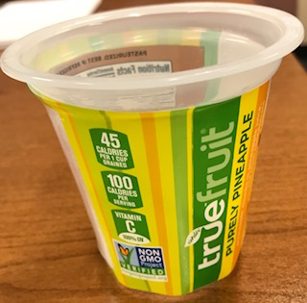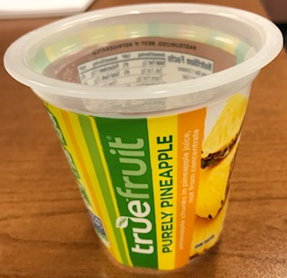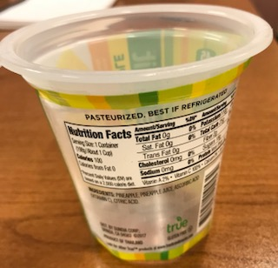

NO because it has ascorbic acid which is a preservative

Vendors
Bad experiences at the grocery stores may be impacting a decrease in caseload
Remember to get feedback about client shopping experience
- Administrative Forms link (state website)
https://health.mo.gov/living/families/wic/wiclwp/pdf/WIC-40.pdf
Food Instruments
Since we are transitioning to eWIC check related Food Instrument Accountability policies are not being updated and will become obsolete. There will be a state plan revision in June 2019
VOIDED checks are being presented to grocery stores
- Remember to void checks properly to avoid double issuance
- The State has the right to exercise the option for local agencies to continue to repay the redeemed amounts
- Checks that are reissued due to custody change DO NOT VOID. These checks should be marked LOST OR STOLEN (this gives the State the ability to track redemption); a WIC-32 needs to be completed and scanned in MOWINS; and a general note stating the circumstances.
eWIC
- The eWIC card will be a chip card
- The items available on card can only be read at the store terminal and at a local agency. Clients will need to physically have card to know what they have available.
- It will take 48 hours for transaction records to be processed because MOWINS is an offline system. Once a card is reported lost it will be considered a ‘hot card’. The card will not be valid once the information has been uploaded to MOWINS.
- The State is on schedule to pilot in May
- Kansas City will be the 1st region for full implementation after the pilot agencies.
- Rollout will be a tedious process as TA’s will have to validate each store and each register in each store to ensure that equipment is functioning properly. Walmart will be a helpful tool in that they are familiar with what is anticipated for eWIC from other states who have implemented the system. The State is not going to provide vendors with kiosks. Self-checkout will not be an option for clients.
- Ernestine is on the Security Committee. Local agencies will have an inventory of cards to maintain because they are numbered.
- The Source Technology printers can be used as regular printers after eWIC implementation if the state has not made plans for other types of uses. The MICR system can be taken out and the printers can be used with regular toner.
Next meeting TBA

